Chintareddy Sudhakar Reddy

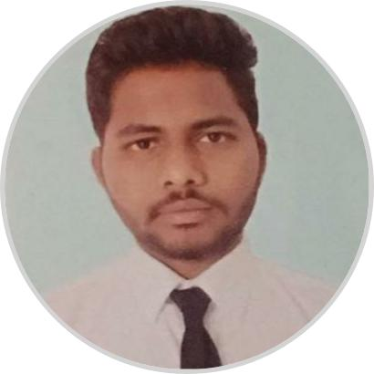

Full Stack developer

An aspiring web developer seeking better understanding of the internet space



chintareddy.sudhakarreddy@gmail.com  9592038184  Hyderabad, India

**EDUCATION**

**B.Tech (Computer Science and Engineering)** Lovely Professional University, Jalandhar

|  |  |
| --- | --- |
| *08/2014 – Present* | *8.22/10* |

**XII (BIEAP)**

Sri Chaitanya Junior College, Vijayawada

*06/2012 – 05/2014* *86.1%*

**X (SSC)**

Sri Chaitanya Techno School, Kodad

*05/2012* *8.5/10*

**SKILLS**



HTML5 CSS3 BootStrap JQuery



JavaScript Java PHP MySQL Ajax c



c++

**ACHIEVEMENTS**

First Prize in an cultural event - One World (10/2016 – 11/2016)

*Represented Nepal in One World event organized by Lovely Professional University*

**PERSONAL PROJECTS**

Student Placement Service (04/2017 – 08/2017)

Web based Application that could provide the placement services to the students, which will take Username and Password to avail the services and if a student doesn’t have account, we will provide the registration process for the same.



Used technologies like html5 ,css3, JavaScript, JQuery, mysql,php,BootStrap and Ajax



Third Prize in an cultural event - One India (03/2017 – 04/2017)

*Represented Telangana in the One India event organized by Lovely Professional University*

**POSITIONS OF RESPONSIBILITY**

National Service Scheme (08/2015 – Present)

*Serves in the National Serves Scheme. Organized Pulse Polio and Blood Donation camps in villages near Lovely Professional University*

Online Shopping (05/2017 – 07/2017)

Web based Application which resembles mostly like the online shopping websites out there. It has all functionalities like a ideal shopping website including diﬀerent sections of men and women clothing.



Used technologies like html5 ,css3 ,JavaScript, JQuery, BootStrap,mysql,php and Ajax



Music Web Application (07/2017 – 08/2017)

Web based Application that could play the songs which are in database and it provides option to user to send a request to admin for songs they need .



Used technologies like html5 ,css3 ,JavaScript, JQuery, BootStrap,php and Mysql



Wikipedia Viewer (10/2017 – Present)

The application can be used to search relevant Wikipedia articles; also provides a link that presents the user with a random article.



Used technologies like JavaScript, JQuery, BootStrap and wikipedia API



Hostel Booking Management System (03/2016 – 04/2016)

I have learnt the implementation of various functions in Java and how to relate them with the database. I have enhanced the security features of the website through intensive firewall system.



Used technologies like java and Mysql.



Student Coordinator - UBSS (09/2016 – 10/2016)

*Worked as a Student Coordinator for Uttar Bharatiya Chattra Sansad, Lovely Professional University*

**CERTIFICATES**

Full Stack Web Development - Udemy (05/2017 – 07/2017)

*Learnt complete web development techniques including HTML5, CSS3, PHP, MySQL, Ajax, JavaScript, JQuery*

Ethical Hacking Workshop (06/2016 – 08/2016)

*Earned Ethical Hacker certificate from Lovely Professional Univeristy. Learnt keylogger's tools and some security tips*

**LANGUAGES**

English



Telugu



Hindi



**INTERESTS**



Dance Fine Arts